COGS 17 A03 Midterm 2 Review

1) (Audition) What is place coding and what structure is involved in place coding?

2) (Audition) The BASE of basilar membrane is ______________________; resonates with/is most displaced by __________(high/low) frequencies; while the APEX of of basilar membrane is ______________________; resonates with/is most displaced by __________(high/low) frequencies; The greater the displacement of the Basilar Membrane, the ________ the Cilia located at that place will be bent, _________ (more/less) NT the Hair Cells will release. As a result, the ________(more/less) likely ________(structure) will reach threshold for _________ Potentials.

3) (Audition) Spiral Ganglions are limited to firing at most 1000 times/second because of their ____________ (what period?), so how do our auditory system code for higher frequencies?

4) (Audition) Briefly explain Volley Principle.

5) (Audition) Localization can use intensity differences, which best works for ________ (high/low) frequencies; also, the auditory system can use phase differences, which best works for _________(high/low) frequencies.

6) (Vision) Fill out the table below:

|  | Receptor Cells | Bipolar Cells | Ganglion Cells | Interneurons |
| --- | --- | --- | --- | --- |
| Which kind of potential? |  |  |  |  |
| Excitatory or inhibitory NT? |  |  |  |  |
| Spontaneous Firing? |  |  |  | N/A |

7) (Vision) Receptor cells are turned _______ (on/off) by light.

8) (Vision) What are the differences between rods and cones?

|  | Rods | Cones |
| --- | --- | --- |
| Size |  |  |
| Amount of Photopigment |  |  |
| Connectivity Pattern |  |  |
| Sensitivity |  |  |
| Acuity |  |  |
| Motion Detection |  |  |
| Code color? |  |  |

9) (Vision) What are the two visual pathways and what are the differences between them?

10) (Vision) Will this motion detector respond to motion from left to right? Why or why not? If possible, draw a graph to demonstrate the process!

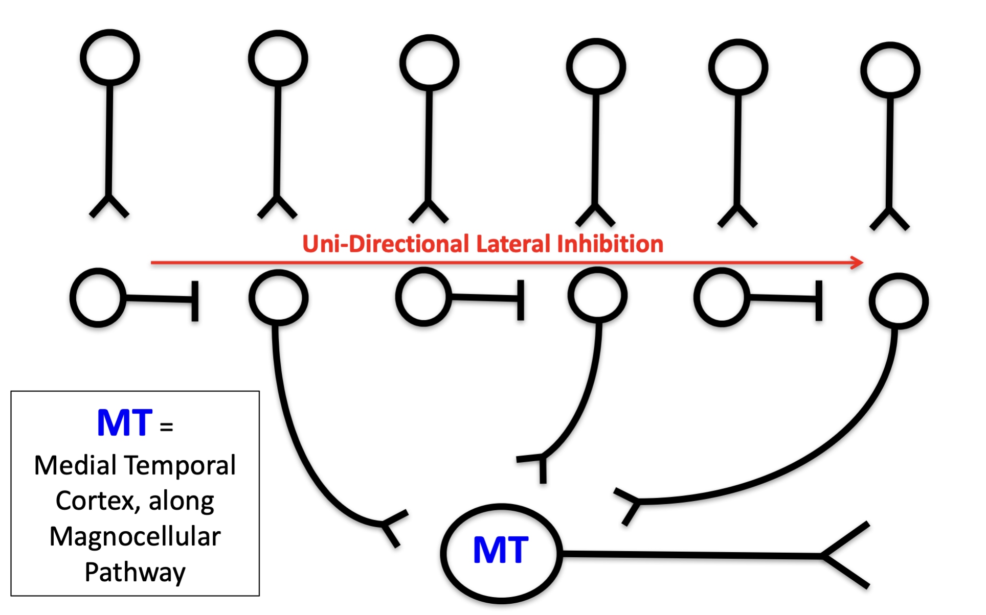

11) (Somatosensory) Which organ detects changes in head tilts? Which structure detects rotations?

12) (Somatosensory) Deforming Hair Cells results in ____________ (action/graded) responses to subtle, 3D changes. Bend cilia toward tallest cilia, _______ (open/close) K+ gates, K+ _______

(enters/leaves), ________ (increase/decrease) spontaneous firing rate;

bend cilia toward shortest cilia, _______ (open/close) K+ gates, K+ _______ (enters/leaves), ________ (increase/decrease) spontaneous firing rate.

13) (Somatosensory) What causes motion sickness?

14) (Somatosensory) What are the differences between the four encapsulated

nerve endings?

|  | Meissner’s | Merkel’s | Pacinian’s | Ruffinni’s |
| --- | --- | --- | --- | --- |
| Receptive Field |  |  |  |  |
| Adapting Speed |  |  |  |  |
| What is it best for? |  |  |  |  |

15) (Somatosensory) If you put your hand in cold water (e.g. 70℉) for a couple

minutes, and then you put your hand in 89℉ water, will you now feel the water

warmer? Why?

16) (Somatosensory) What are the two main pathways for somatosensory

Information? What are the differences between them (where the information

crosses over & what kind of information that it passes)?

17) (Somatosensory) What is Gate Theory?

18) (Motor) What are the two main motor pathways and what are the differences?

19) (Motor) What are the main functions of the cerebellum? How does it code for

time?

20) (Motor) What are the main functions of the basal ganglia?